Assignment 24.
- How many watch points can be created?
- We can create a maximum of 10 watchpoints in a single debugging session.

- How to add your data from desktop to your internal table in debugging?
- We can import data into an internal table during debugging by using the Import icon in the Table Contents tab of the debugger, or alternatively by manually entering values row by row in the Table tab, or by modifying variable values by double-clicking on the field.

- How to check write statements in debugging?
- In the New ABAP Debugger, if the "Display List" option is missing from the standard menus, follow these steps to monitor WRITE statement output
- Open New Tool: In any pane of the debugger (e.g., on the right side), click the New Tool icon (resembles a hammer and wrench).
- 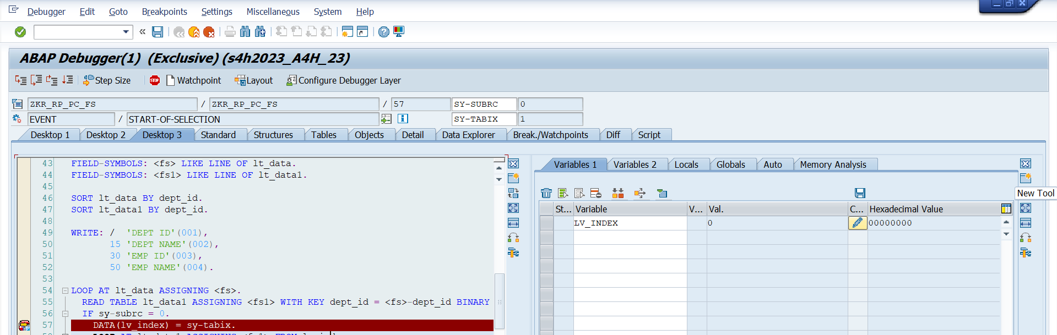
- 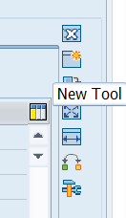 (Screen right side)
- Select Special Tools: In the popup, expand the Special Tools folder.
- Choose Preview: Double-click on Console: XML and List Preview.
- 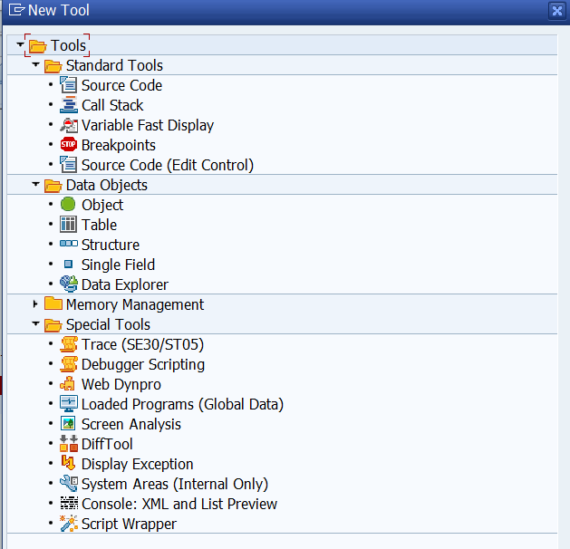
- View Output: Click the ABAP List tab within that tool.
The output will now update in real-time as you step through the code (F5/F6).
- 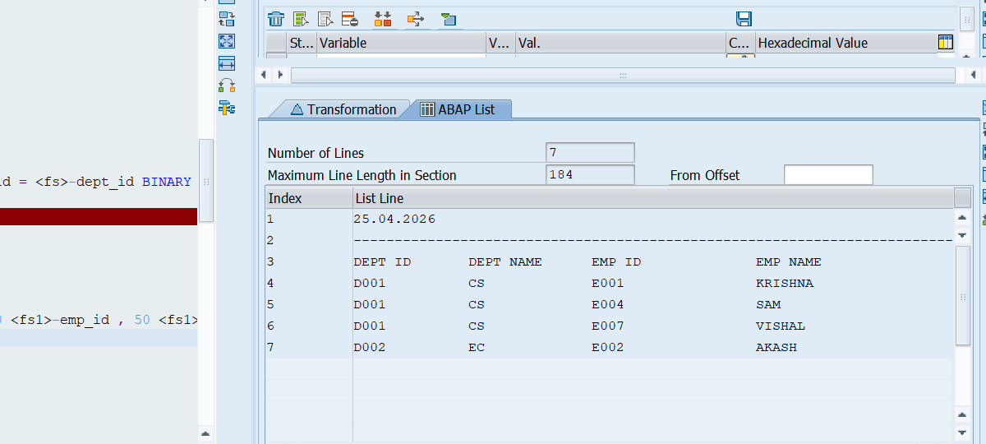
- How we can change internal table data in debugging?
- Changing internal table data in debugging means modifying the values of an internal table during runtime using the debugger, without changing the actual program code.
- Use this to edit data inside an internal table like LT_ORDERS or LT_EMPLOYEES.
- Open the debugger and click the Table tab at the top.
- Type your internal table name (e.g. LT_EMPLOYEES) in the input field and press Enter.
- The table rows and columns appear. Double-click any cell value to make it editable.
- Type the new value and press Enter to confirm. The change takes effect immediately in memory.
- Select lt_data by double click on it.

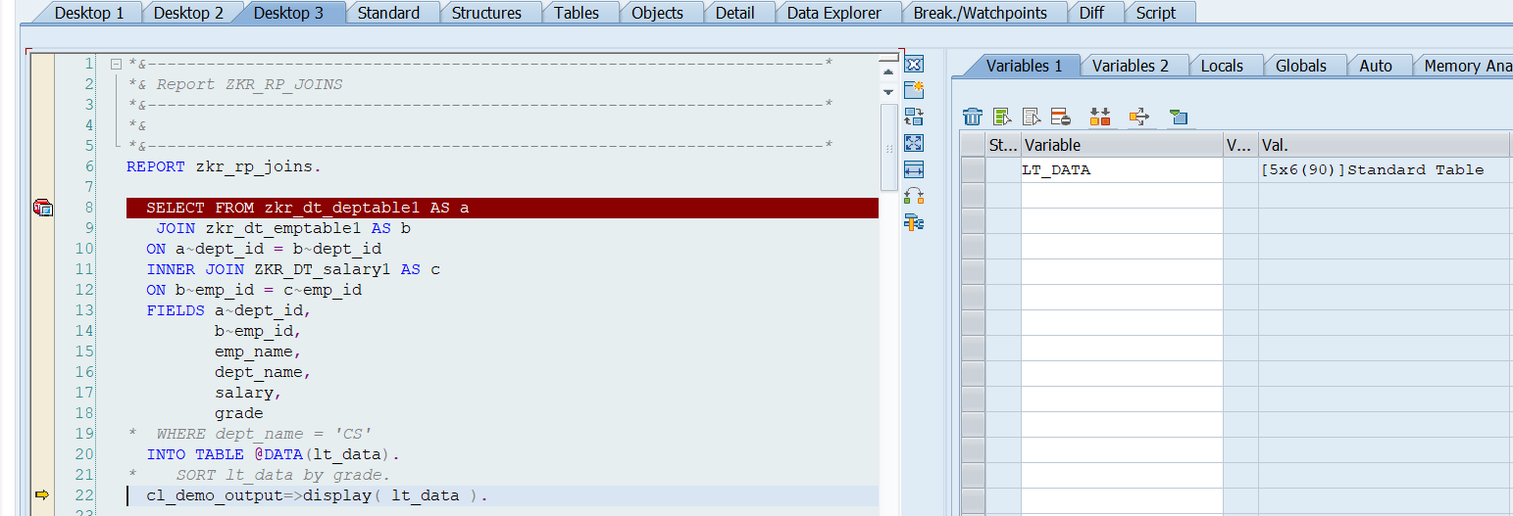

- and after double click on LT_DATA in right side(Above image), then table content will be displayed.
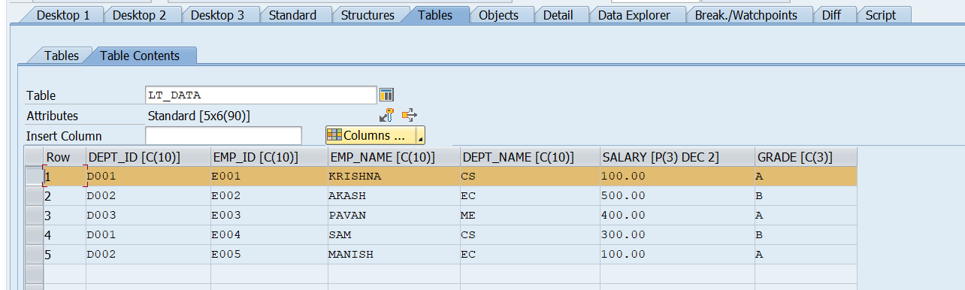

- Double click on row number that we want to edit the internal table data.
- 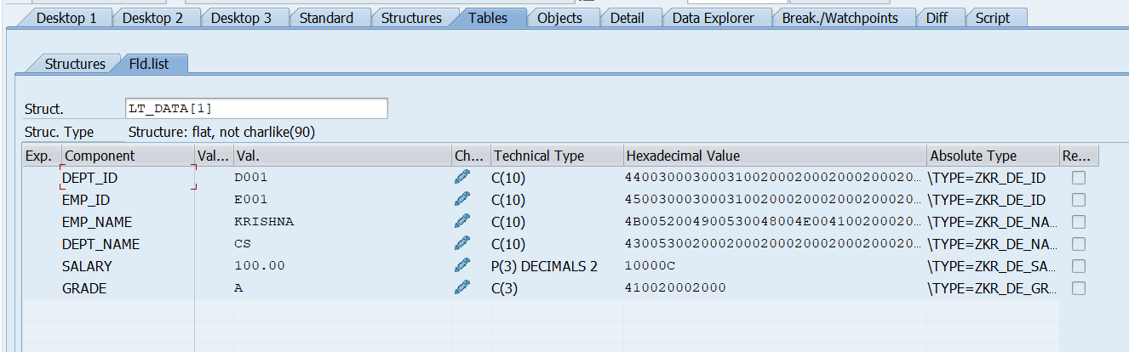
- Changed the name from KRISHNA to VISHAL and click enter.
- 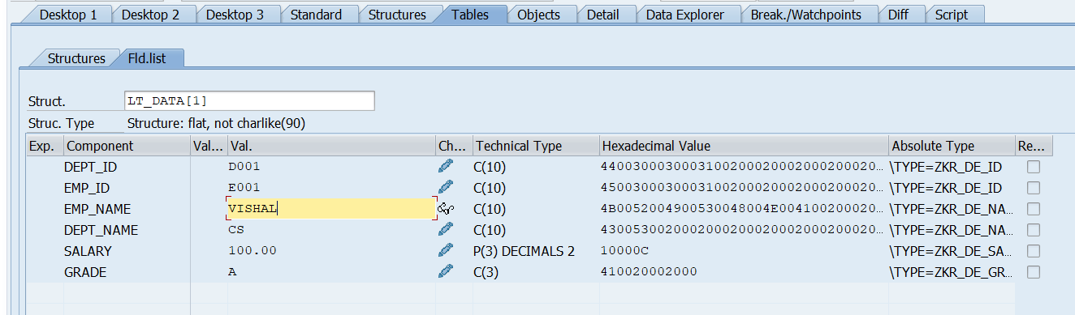
- Before editing the data.
- 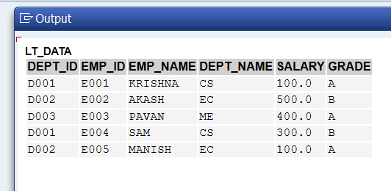
- After editing the data.
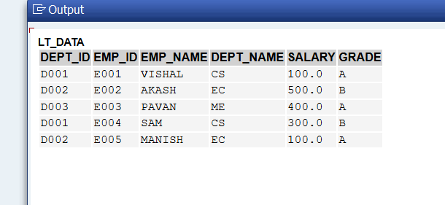

- How to compare variables inside debugging?
- During debugging, comparing variables helps identify differences in values, track changes, and detect errors in logic. The ABAP Debugger provides multiple ways to compare variables.
- 1. Run program in debug mode
- 2. Click "Desktop 1" tab
- 3. Type first variable name → press Enter
- 4. Type second variable name → press Enter
- 5. Both values show side by side → compare visually!
or
- Open Debugger (/h → F8)
- Go to Diff tab
- Add two variables for comparison
- Execute step-by-step
or
- 1. Click "Diff" tab in debugger
- 2. Enter Variable 1 name on LEFT side
- 3. Enter Variable 2 name on RIGHT side
- 4. Differences highlighted automatically!
or
- Watchpoint Comparison
- 1. Right click on variable
- 2. Select "Create Watchpoint"
- 3. Set condition like:
- LV_SALARY > 50000
- 4. Press F8 → debugger stops
- automatically when condition is TRUE!
- Step1: Open debugger
- 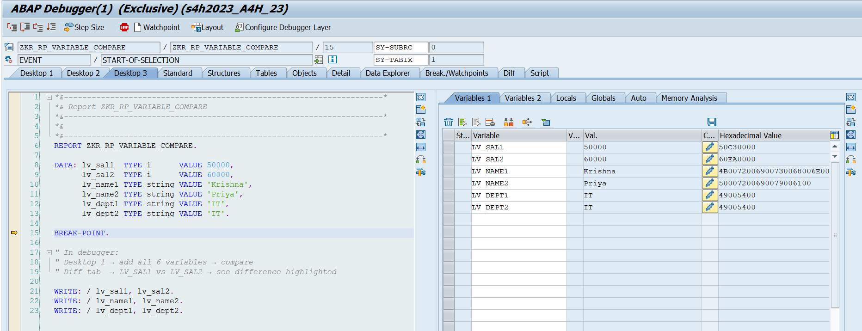

- Step2: click on Diff Tab
- 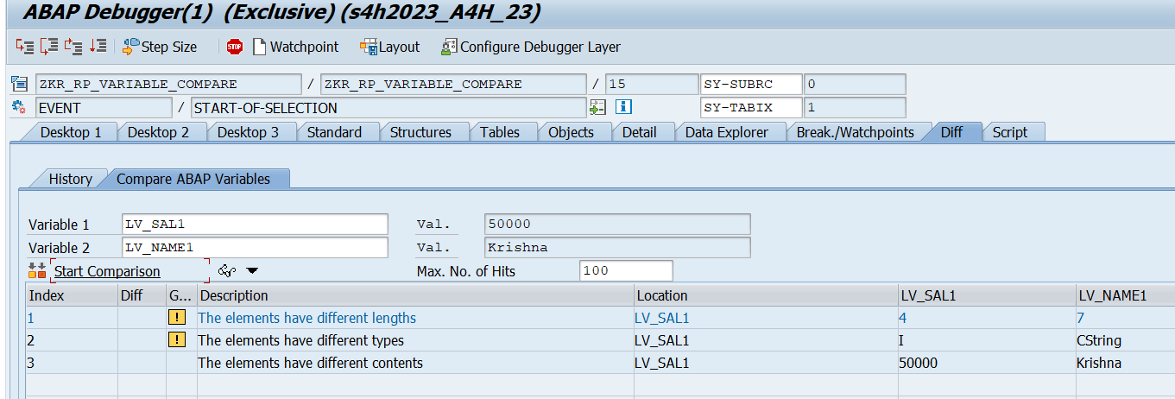
- Step3: Add two variables for comparison
- 
- Step4: click on Start Comparison


- What are the function keys used in debugging?
- Function keys in the ABAP Debugger are used to control program execution step-by-step, helping developers analyze logic and find errors efficiently.
- F5 – Single Step (Step Into)
- Executes one statement at a time
- Enters into called functions, methods, or subroutines
- F6 – Execute (Step Over)
- Executes one statement
- Does NOT go inside function/module/method
- F7 – Return (Step Out)
- Executes remaining code of current block
- Returns to calling program
- F8 – Continue
- Runs the program until next breakpoint
- Shift + F8 – Continue to Cursor
- Executes program up to the selected line (cursor position)
- Faster than multiple F8 steps
- Shift + F12 – Stop Debugging
- Ends debugging session
- Program execution stops
- Difference between Breakpoints and Watchpoints?

Feature | Breakpoint | Watchpoint
Purpose | Stops execution at a specific line | Stops when condition is met
Based On | Line of code | Variable value
Trigger | Always stops at that line | Stops only when condition is true
Setup | Set manually on a line | Set on a variable with condition
Use Case | Check flow of program | Track value changes
Flexibility | Less flexible | More flexible
Performance Impact | Minimal | Slightly higher (monitors variable)

- How many external breakpoints is possible in session?
- Maximum 30 external breakpoints per user session in SAP ABAP.

- How to deactivate breakpoint in runtime and how to delete breakpoint at runtime?
- Deactivate breakpoint at runtime:
- Method 1-
- In Debugger:
- 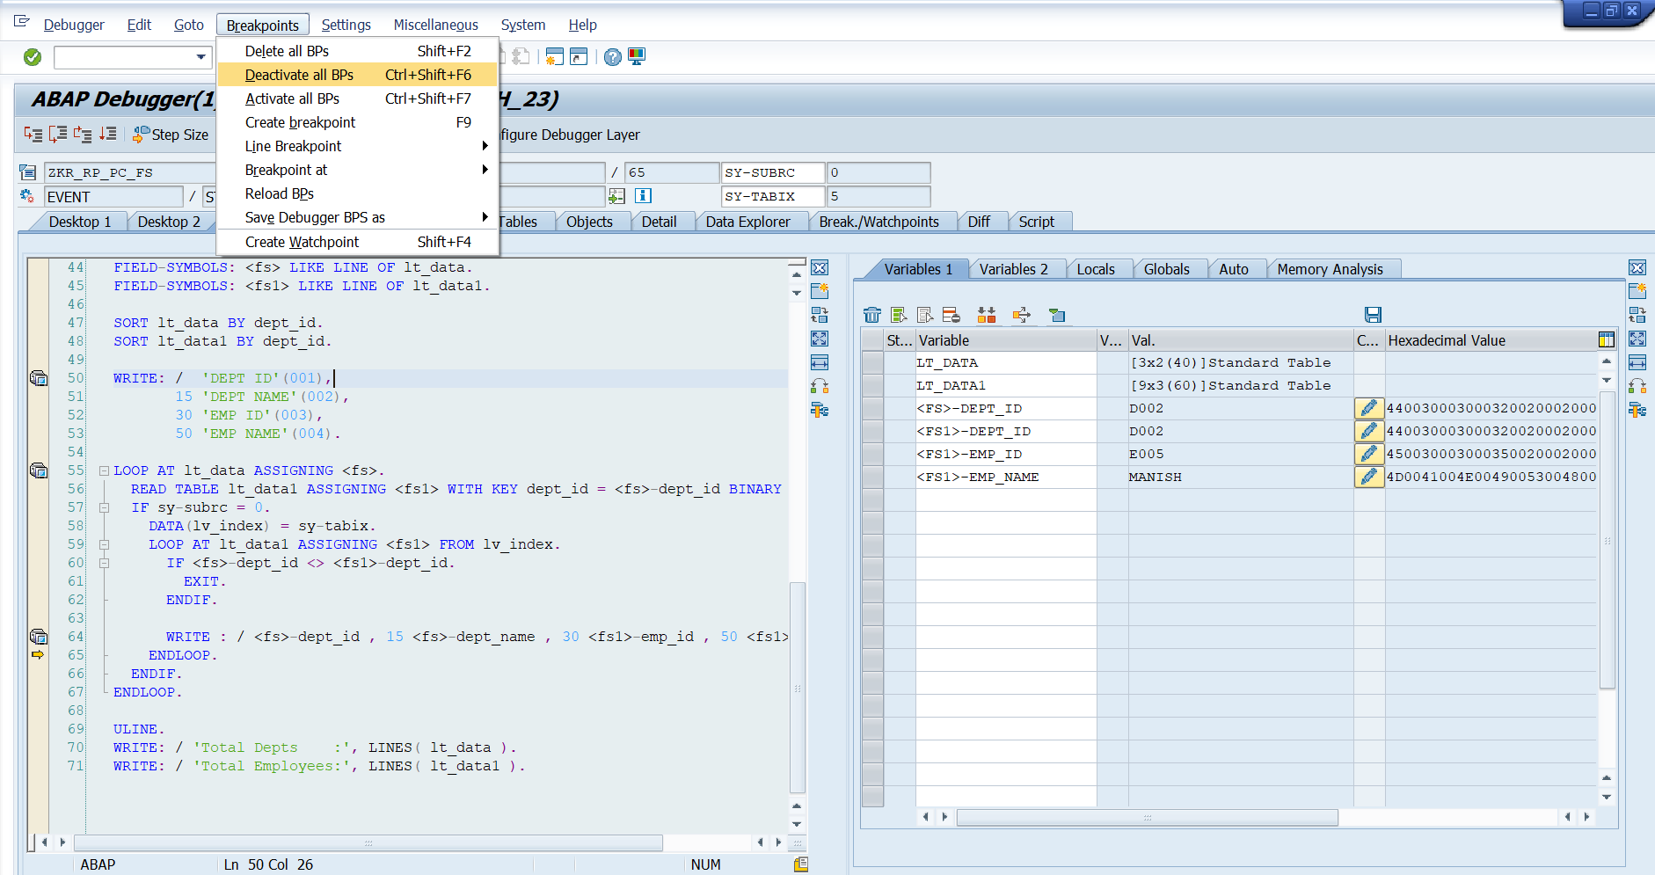
- Step 1 → Click "Breakpoints" menu
- Step 2 → Click "Deactivate all BPs" (Ctrl + Shift + F6)
- Step 3 → All breakpoints go GREY = deactivated but still exist!

- To reactivate:
- 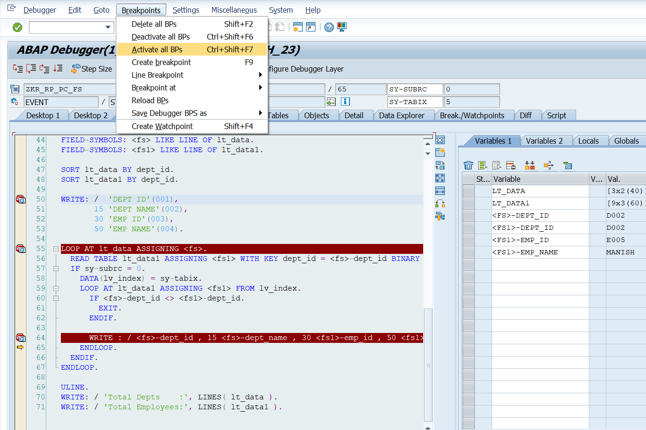
- Step 1 → Click "Breakpoints" menu
- Step 2 → Click "Activate all BPs" (Ctrl + Shift + F7)
- Step 3 → All breakpoints go RED = active again!
- Method 2-
- 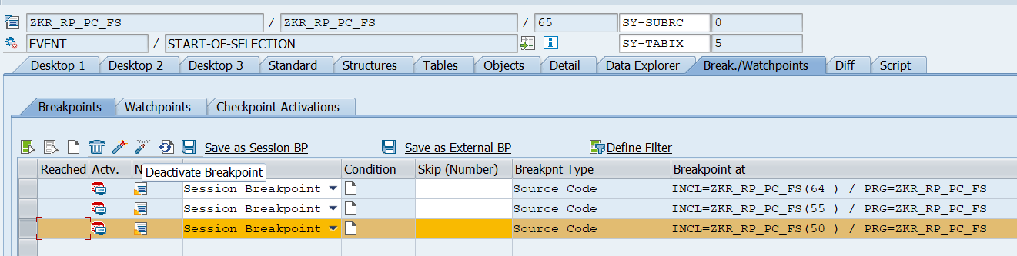
- Step 1 → Click "Breakpoints" menu
- Step 2 → Click "Break./Watchpoints" tab in debugger
- Step 3 → You see list of all breakpoints
- Step 4 → UNCHECK the checkbox next to specific breakpoint
- Step 5 → That one breakpoint deactivated! Others still active
- Delete Breakpoint at Runtime:
- Method 1 — Delete ALL breakpoints-
- In Debugger:
- 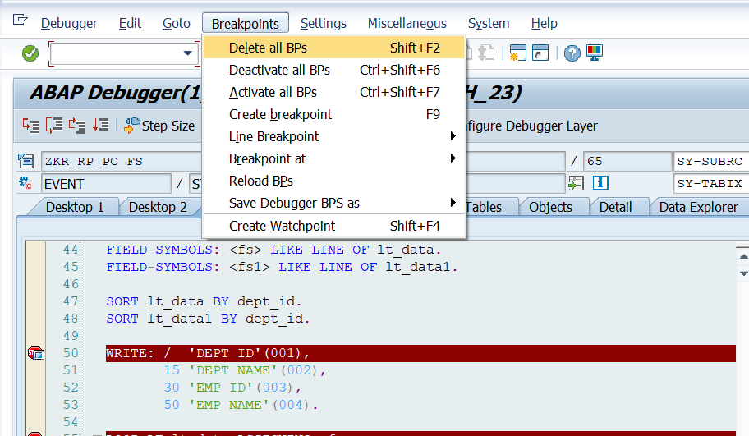
- Step 1 → Click "Breakpoints" menu
- Step 2 → Click "Delete all BPs" (Shift + F2)
- Step 3 → ALL breakpoints deleted! Program runs to end without stopping

- In Debugger:
- 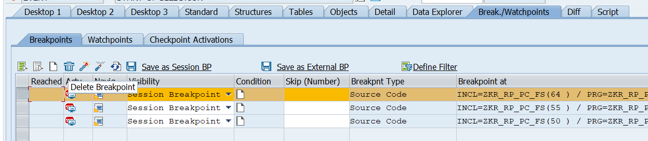
- Step 1 → Go to "Break./Watchpoints" tab
- Step 2 → Select specific breakpoint from the list
- Step 3 → Click DELETE button or press DELETE key
- Step 4 → Only that breakpoint removed Others still exist

- What is the use stack?

